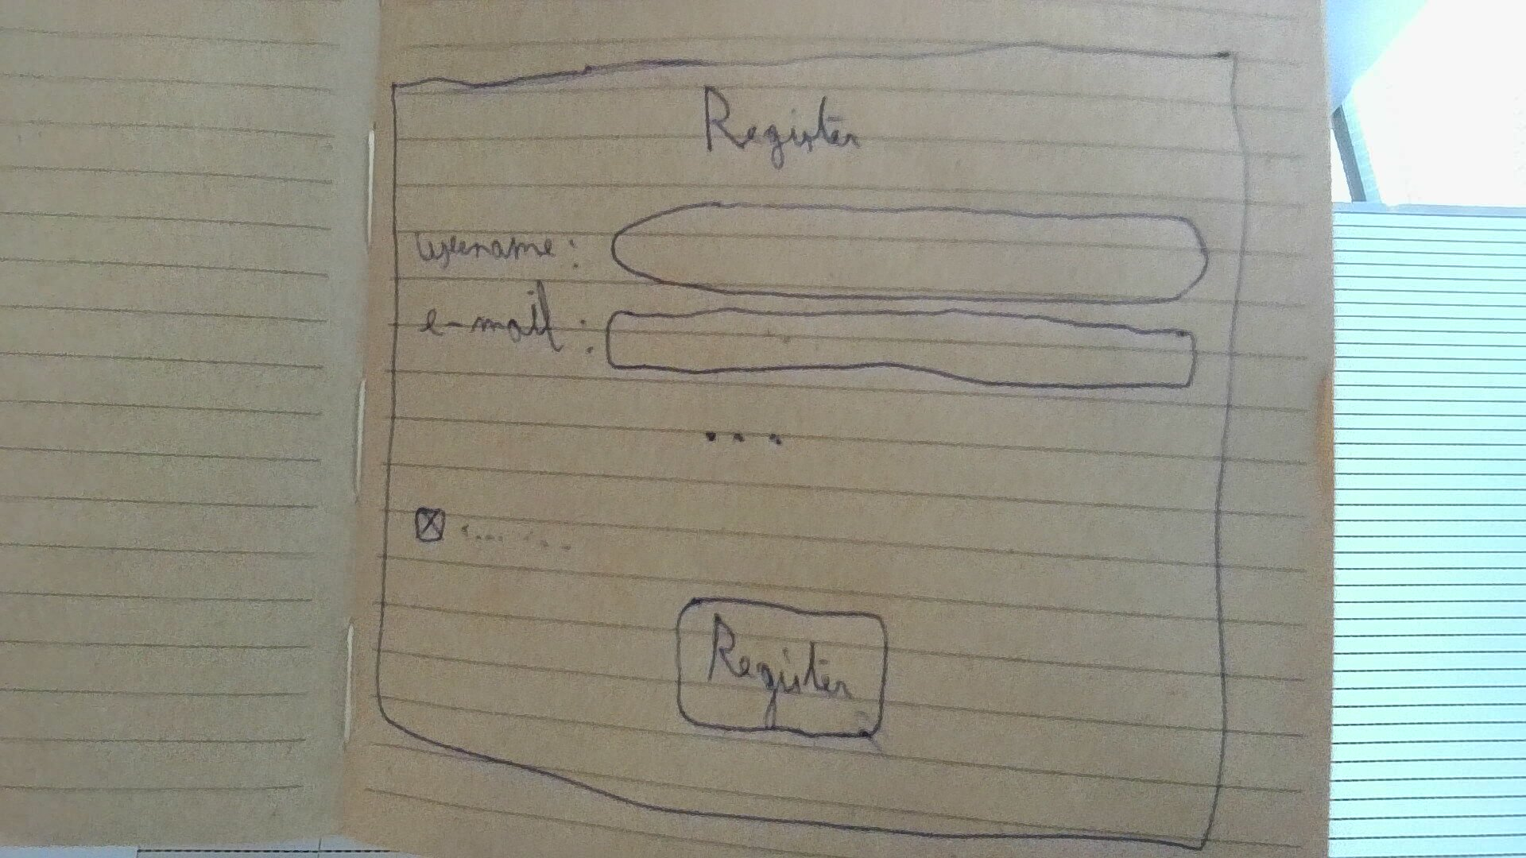
STORY – OVERVIEW COUNTERS
As a user
I’m able to make an account
So that I can use the application.
WIREFRAME

ACCEPTANCE CRITERIA
- You get a registration page asking for a username, e-mail, phone number and password
- The values need to be validated (with fitting errors)
- After entering valid values and clicking a button you get redirected to the next page

STORY – OVERVIEW COUNTERS
As a user
I’m able to browse a list of relevant offers
So that I can find things to lend
WIREFRAME

ACCEPTANCE CRITERIA
- The page shows offers from the area and the offers are clickable
- Specific filters can be added like category or price
- You can sort the offers by price or distance
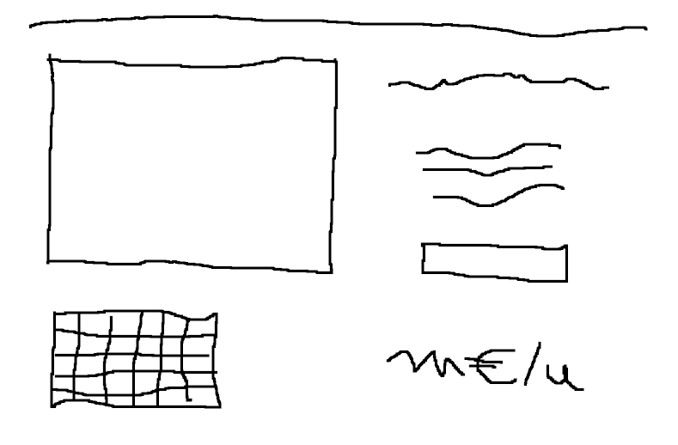
STORY – OVERVIEW COUNTERS
As a user
I’m able to view the details of an offer
So that I can decide if I want to book it
WIREFRAME

ACCEPTANCE CRITERIA
- The page shows the details of the offer
- You can click a button to book the offer
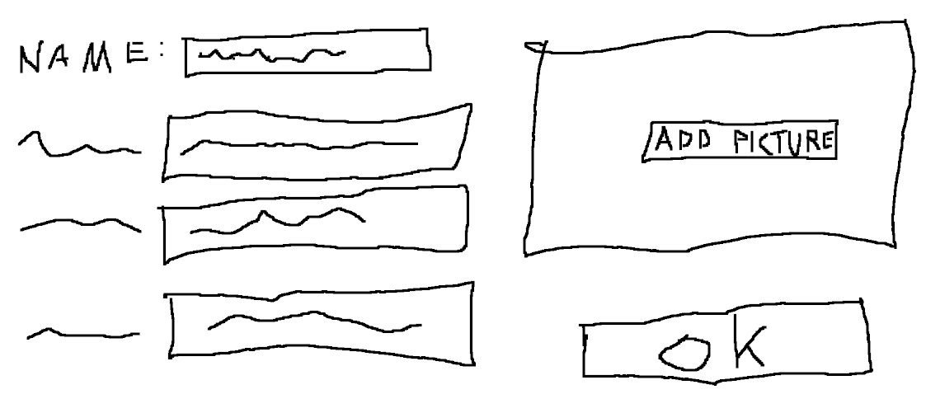
STORY – OVERVIEW COUNTERS
As a user
I’m able to make a new offer
So somebody can lend my things
WIREFRAME

ACCEPTANCE CRITERIA
- A button from the main page leads you to a creation form
- You have to put in a picture, description, select categories, Price (per time unit) and availabilities
- There is validation on the values you have to put in
- In case of invalid values you get an appropriate error message
STORY – OVERVIEW COUNTERS
As a user
I’m able to view a list with the offers I put on the site
So that I can manage them
WIREFRAME

ACCEPTANCE CRITERIA
- The page shows the orders you currently have online
- You can check if and when they have been booked
- You should be able to sort the page by name, price (per time unit) and date of creation
STORY – OVERVIEW COUNTERS
As a user
I’m able to edit my offers
So that I can change or delete offers
WIREFRAME

ACCEPTANCE CRITERIA
DELETE
- This page should allow you to edit the data in each of the fields
- This page should have a delete button for the offer
- The new data should be validated.
- In case of invalid data you get an appropriate error message

